Approximation Algorithms for Multiple Sequence Alignment
Theoretical Computer Science 1997, Vol. 182, pp. 233-244
Vineet Bafna, Eugene L. Lawler and Pavel A. Pevzner
Abstract
The MSA problem based on pairwise alignment has a approximation rate of 2-2/k (in 1997) while having k sequences. The authors reduce the problem to graph concept and get the approximation rate of 2-l/k.
- Definition
The pair-wise alignment with a weighted score (distance) for the alignment A is: 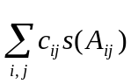 while aligning the ith and the jth sequence. c is the weight and s is the score.

Let S(A)=[s(A_{ij})]be the matrix of scores (distance) of pairs of sequence, so the weighted sum-of-pair score is CS(A).

Let E be the unit matrix consisting of all 1’s except the main diagonal consisting of all 0’s, the unweighted sum-of-pair score is ES(A).

5-star graph:
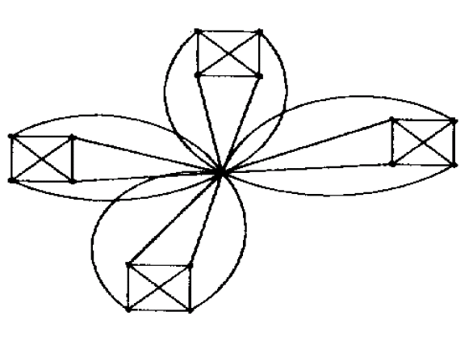
17 vertices with clique size of 5
it contains (17-1)/(5-1)=4 cliques

Balanced set of l-stars: Let g be the collection of l-stars, C(G) denotes the weight matrix for star G. If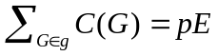 g is balanced. When g is a balance set, it contains all possible permutation on l-star graph.
- Basic Ideas
Map the sequences to the vertices. Assign weights to edges of an l-star graph G with one center string:
k-(l-1) i=c or j=c
c_{ij}={ 1 i,j≠c i and j are contained in the same clique
- otherwise
The sum of all edges with weight is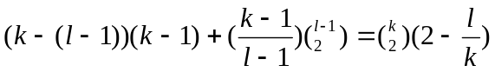

Lemma1: 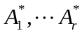.be the optimal weighted sum-of-pairs alignments for the r cliques. There would be an alignment A compatible with each of the alignments .

Lemma2: For any alignment A in l-star G, ES(A)≦C(G)S(A)
Cause s(A_{ij}) ≦s(A_{ik})+s(A_{kj})

Lemma3: Given an l-star G, there is an optimal alignment A_{G} for the k sequences that is compatible with each of the alignments.Moreover, 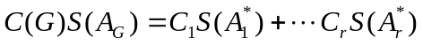
Cause Lemma1 and d(-,-)=0

Lemma4: If g is a balanced set of l-stars,then:
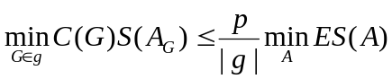
Cause 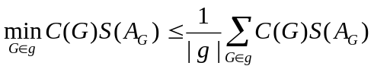
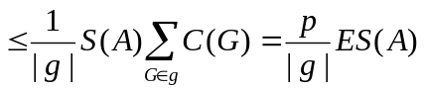
- Method
- Construct a balanced set of l-stars, g.
- For each l-star G in g, assemble an alignment A_{G} that is optimal with respect to C(G) from alignments that are optimal for each of its cliques (Lemma3).
- Choose G with the corresponding alignment A_{G} such that C(G)S(A_{G}) is the minimum over all l-stars in g.
- Return A_{G.}

Note that: 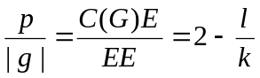
Above procedure returns the alignment AG which is optimal for l-star Gg, and for which the smallest weighted score, 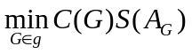is achieved. Lemma2 and 4 imply that 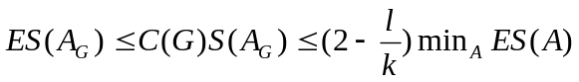
- Conclusion

Created by: Chia-Ling Sun
Date : Oct. 24, 2003

